St. Bridget Catholic Church
2025-2026 Middle School Religious Education Calendar
Formation for all students in 6th through 8th grade takes place in the Saint Bridget Middle School building, from 10:30 AM – 12:00 PM.
For questions regarding Religious Education/Youth Ministry for 6th – 12th grade, including Confirmation Preparation, please contact Patrick Stearman at pstearman@saintbirdgetchurch.org or 804-525-9382, ext. 334.

August
17th – Parent + Youth Orientations
24th – Session 1, “Person of Christ”
30th – No Class
September
7th – Session 2,
“Who do you say that I am?”
14th – Ministry Fair and Parish Picnic
21st – Session 4, “1+1+1=1”
26th – 27th – Cardboard Box City Event
(Overnight) *Separate Registration*
28 – No Class
October
5th – Session 5, “Hypostatic Union”
9th – Life Teen Summer Camp Registration Requests Due
12th – No Class
19th – Session 6, “Call Me Mom”
26th – Session 7,
“Head, Shoulder, Knees and Toes”
November
2nd – No Class ; Optional Virtus Session
9th – Session 8, “Connected”
16th – Session 9, “Battle Ready”
23rd – Session 10, “Called to Action”
30th – No Class
December
7th – Session 11, “Revelation, God’s Gift”
9th – Session 12, “In Pursuit”
16th – Session 13, “Chain Reaction”
21st – Session 14, “Gimme A Break”
28th – No Class
January
4th – No Class
11th – Session 15,
“What’s Your Sabbath?”
18th – No Class
25th – Session 16, “Gifted”

February
1st – Session 17, “News Feed”
8th – Session 18, “Legit Defense”
15th – No Class
22nd – No Class (DYC, Open to 8th Grade)
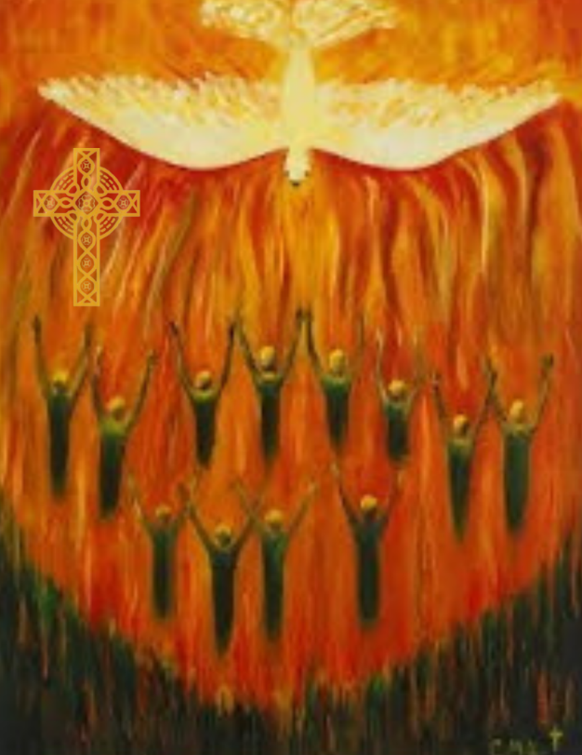
March
1st – Session 20, “Happy Days”
8th – No Class (Spring Break)
15th – Session 21
“Blessed Virgin Mary”
22nd – Session 22
“Queen of Heaven”
29th – No Class
April
5th – No Class
12th – Session 23
“Immaculate Conception and Assumption”
19th – Session 24,
“End of Year Party”

